Appendix 2: Mock designs of the product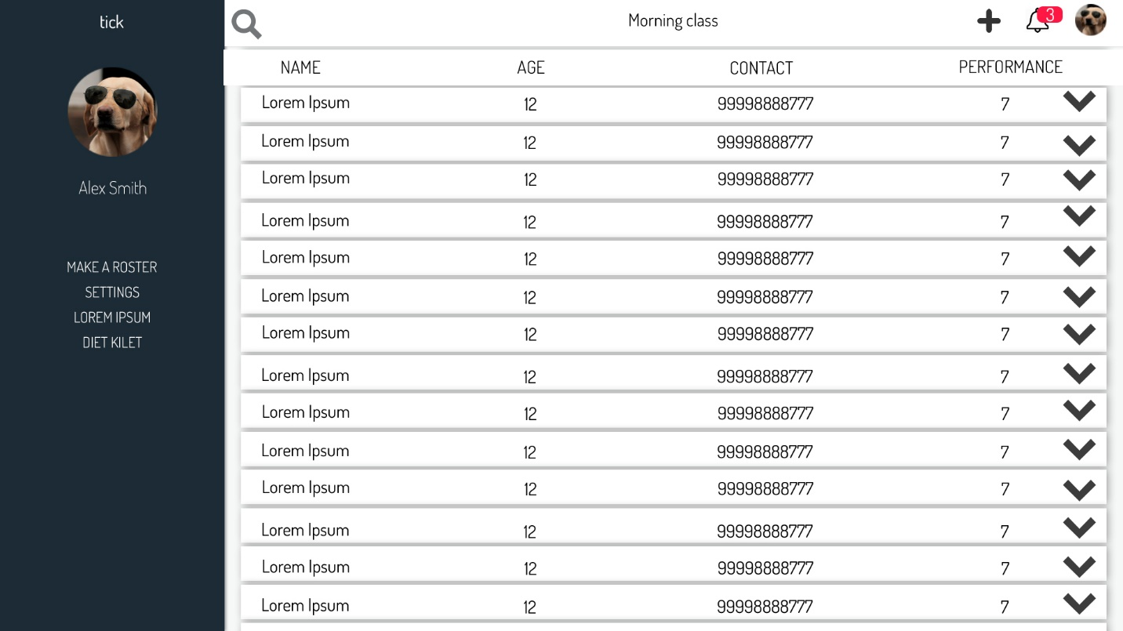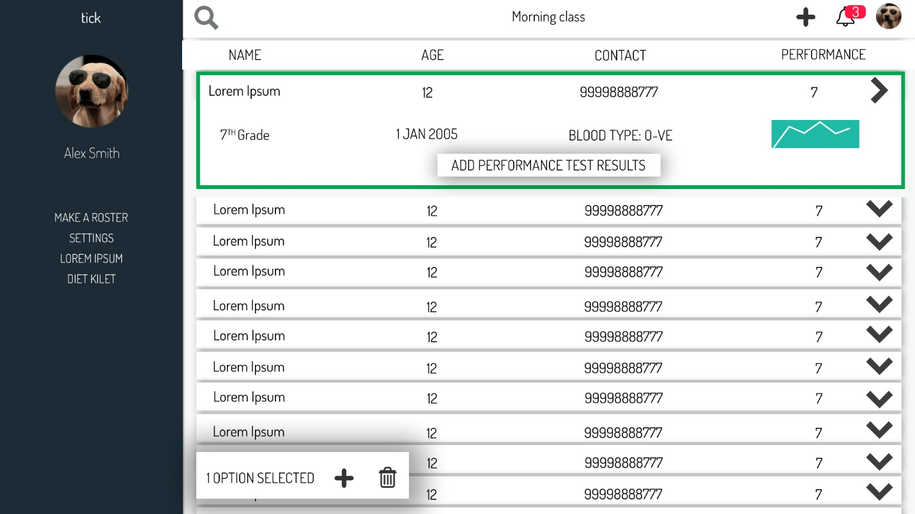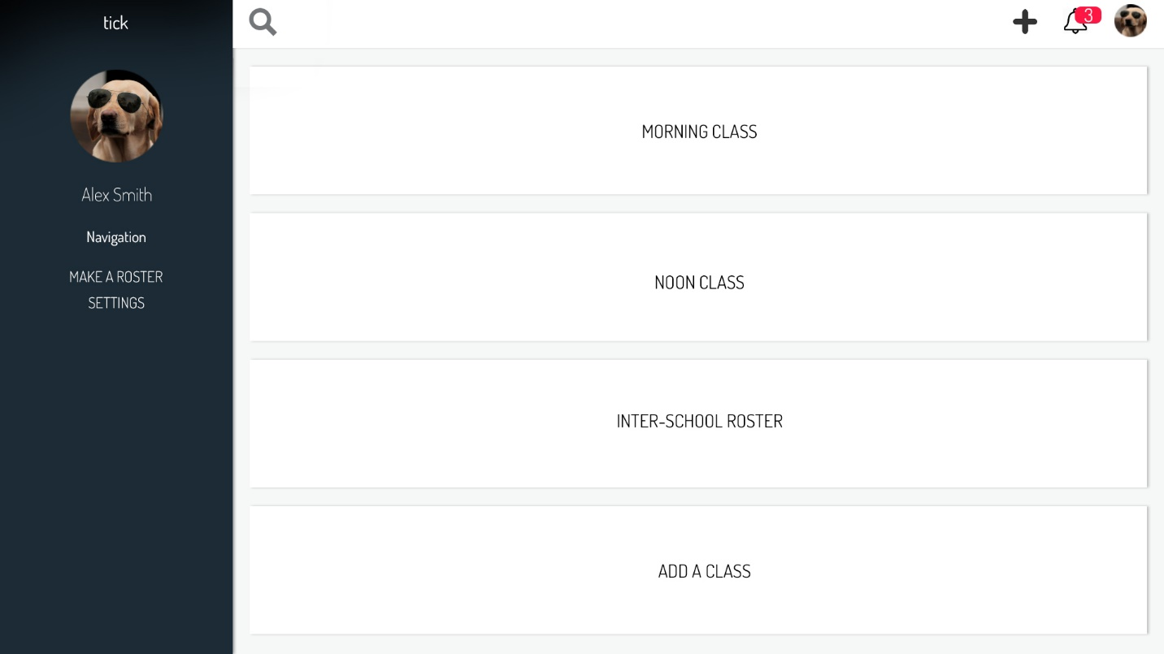

NOTE: These designs were made by me in photoshop. I have been working as a freelance GFX, VFX, and UI/UX designer for 3+ years. Which is the reason why these designs are extremely clean and minimalistic. These designs served as the foundation of the product, due to time constraints and complexity some of the design features could not have been implemented in time.